Name:  Teacher : | ____________________________________  ______________________ |  | Date:_________
 | Year 12 Foundation  /22  Finances Test 1  Full working out MUST be shown to get full marks for each question.
Total Time: | 30 minutes
Weighting: | 5%
Equipment: | To be provided by the student: Pen, pencil, ruler, scientific calculator

Steven has a part time job. He works 35 hours a week, and earns minimum wage
- Find the minimum wage for an 18 year old, and work out Steven’s income [2]

- Steven creates a budget and lists his weekly expenditures. Fill in the following totals: [9 marks – ½ each]

 | WEEK 1 | WEEK 2 | WEEK 3 | WEEK 4 | TOTAL
Petrol | $75 | $75 | $75 | $75
Food | $150 | $150 | $150 | $150
Entertainment | $55 | $55 | $55 | $55
Bills | $96.50 | $96.50 | $96.50 | $96.50
Insurances | $66.50 | $45.20 | $66.50 | $45.20
Rent | $175 | $175 | $175 | $175
TOTAL
INCOME:
(Q1 answer)
DIFFERENCE: |  |  |  |  |  | <- Monthly savings

- Steven needs to save $2500. How could he do this? [2 marks]


Steven wants to refurnish the games room and he is interested to buy the following:

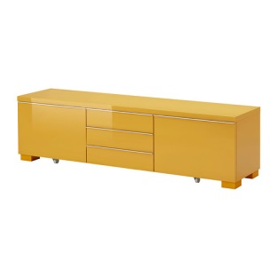


TV $745 X-box $479 TV bench $299 Sofa bed $245

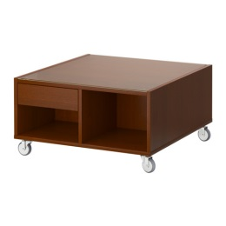


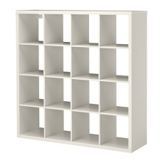

Futon $150 Lamp $56.50 Bookcase $176 Coffee table $129.50

- Calculate the total cost. Show all working using place value, partition or any strategy. [2]

- If Steven saved the $2500, how much change would he receive if any? Show all working or explain your strategy. [4]

- Steven gets a job paying him $21.50. How long would it take him to save the $2500 if his budget remained the same?

END OF ASSESSMENT

Steven has a part time job. He works 35 hours a week, and earns $21.50 per hour.
- Calculate his total income for 1 week.

35 x 21.50 = $752.20
- Total hours
- Mulitplied by Hourly rate
- Total income.

- Steven creates a budget and lists his weekly expenditures. Fill in the following totals: [9 marks – ½ each]
 | WEEK 1 | WEEK 2 | WEEK 3 | WEEK 4 | TOTAL
Petrol | $75 | $75 | $75 | $75 | $300 | 1
Food | $150 | $150 | $150 | $150 | $600 | 1
Entertainment | $55 | $55 | $55 | $55 | $220 | 1
Bills | $96.50 | $96.50 | $96.50 | $96.50 | $386 | 1
Insurances | $66.50 | $45.20 | $66.50 | $45.20 | $223 | 1
Rent | $175 | $175 | $175 | $175 | $700 | 1
TOTAL | $618 | $597 | $618 | $597 | $2,429 | 5
INCOME: | 752.5 | 752.5 | 752.5 | 752.5 | $3,010 | 2(incomes + tot)
DIFFERENCE: | $135 | $156 | $135 | $156 | $581 | 5

- Based on his monthly savings, how long would it take Steven to save up $2500 [4 marks]

2500 / 581 = 4.3 ~ 5 months = $2905 after 5 months.

- Identify divide,
- Use the correct numbers
- Get the correct months
- Round to 5 months


Steven wants to refurnish the games room and he is interested to buy the following:




TV $745 X-box $479 TV bench $299 Sofa bed $245






Futon $150 Lamp $56.50 Bookcase $176 Coffee table $129.50

- Calculate the total cost. Show all working using place value, partition or any strategy. [2]

745 + 479 + 299 + 245 + 150 + 56.50 + 176 + 129.50 = $2,289
- Adds all numbers
- Get correct answer

- If Steven saved the $2500, how much change would he receive if any? Show all working or explain your strategy. [4]

2500 – 2289 = $211 change

STRAT: I used the calculator, and subtracted the cost of the furniture from the 2500 he had.

- Subtract
- Correct integers
- Correct answer
- Strategy used is listed

END OF ASSESSMENT

